Project Name: property Finder

TA Name: Radwa Moustafa

Team ID: 18

|  |  |  |  |
| --- | --- | --- | --- |
| Department | level | Seat number | الاسم |
| AI | 2 | 20231700217 | جوي أشرف دريهم يونان |
| AI | 2 | 20231700208 | أسماء وليد سيد معوض |
| AI | 2 | 20231700213 | تقى حسنى محمود |
| AI | 2 | 20231700249 | مهرائيل ساويرس معوض شحاته |
| AI | 2 | 20231700226 | سماء حسام محمد صابر |
| AI | 2 | 20231700222 | ريناد اسامة محمود الحسيني |
| AI | 2 | 20231700223 | ريهام ماهر رشدي |

**SQL Script:**

**1st DDL commands (Create Table Statements):**

**2nd DML commands (Create Table Statements):**



4 Canvases interfaces:

1st:

2nd:

3rd:

4th:

Detailed Screenshots:

* set trigger from smart triggers ‘When_button_pressed’ to set the functionality of push button

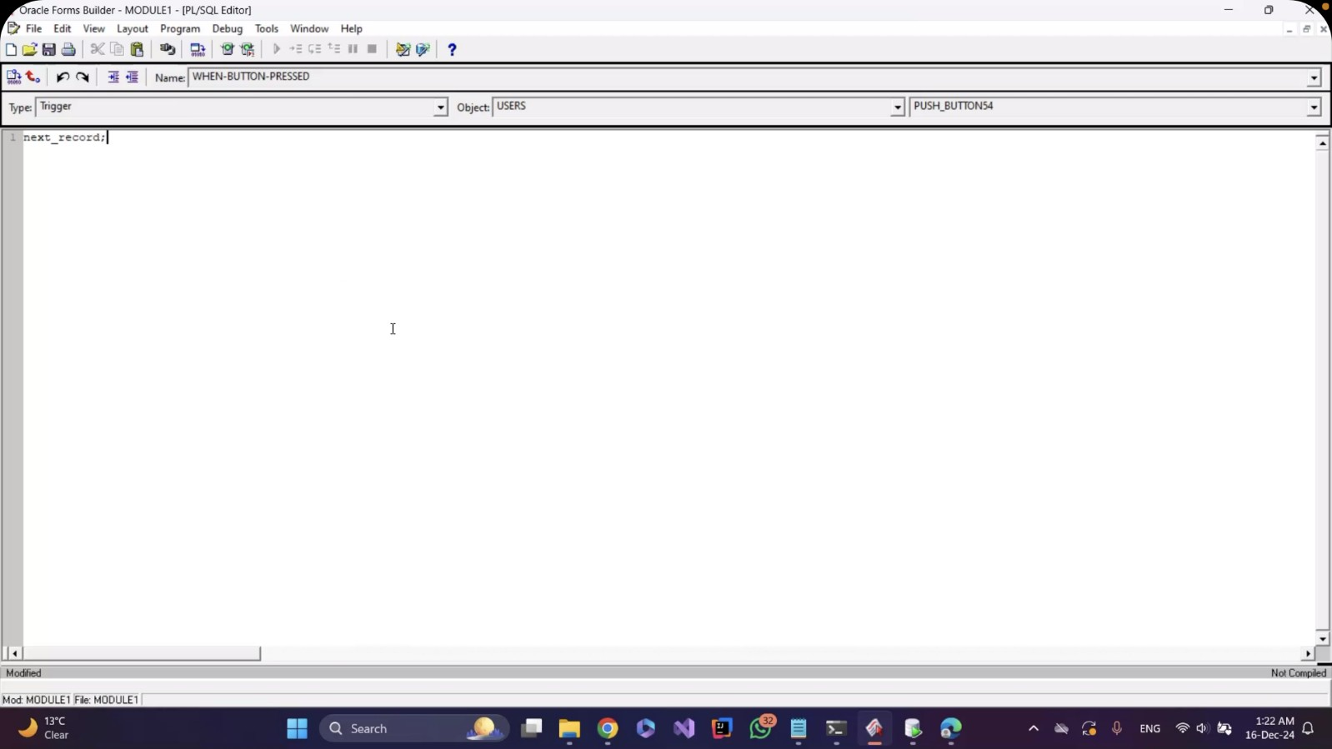

* Short help text that displays "show next record" when you navigate to the push button (next user) with the mouse.

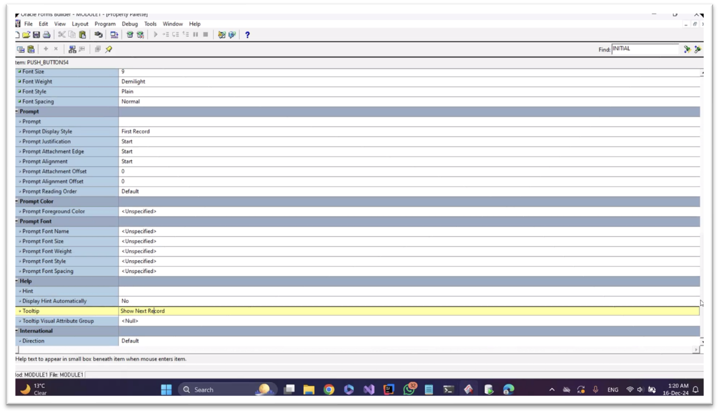

Set the label of the radio button and the value.

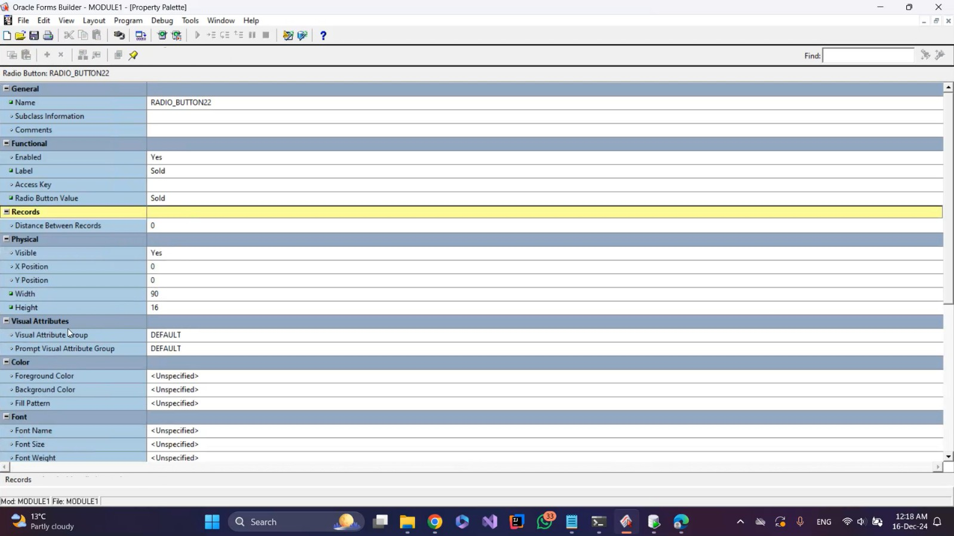

* Set the label and the value for the second radio button

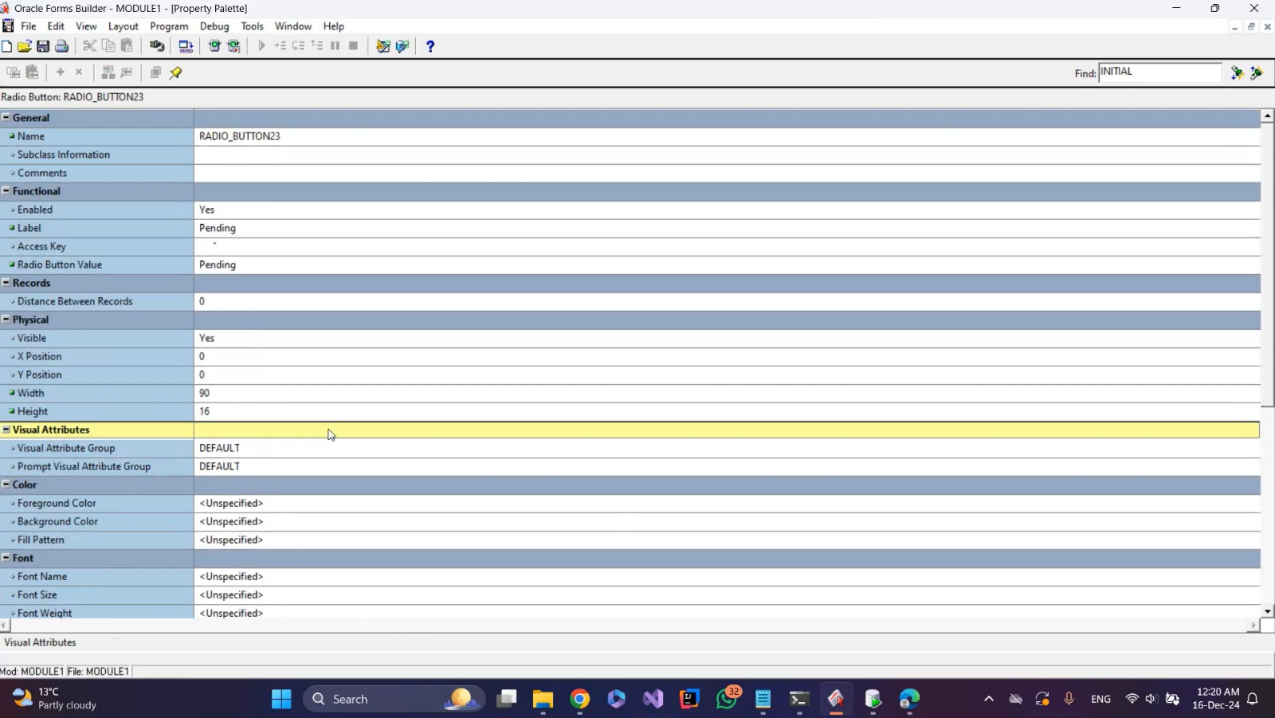

Set the label and the value for the third radio button.

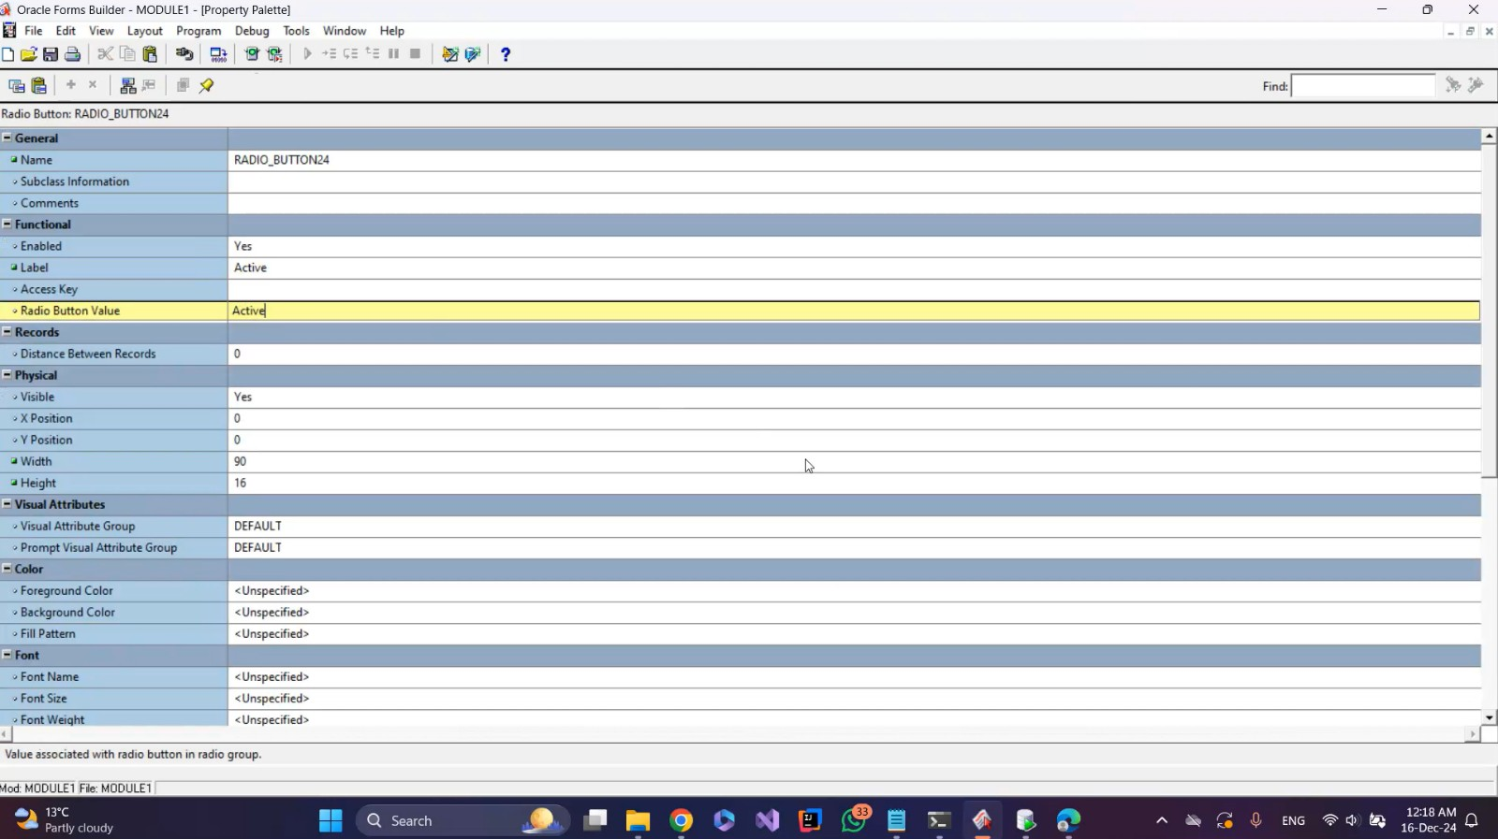

* Put a checkbox for user type and set value when checked (buyer), value when unchecked (renter), mapping of other values (unchecked), initial value (buyer).

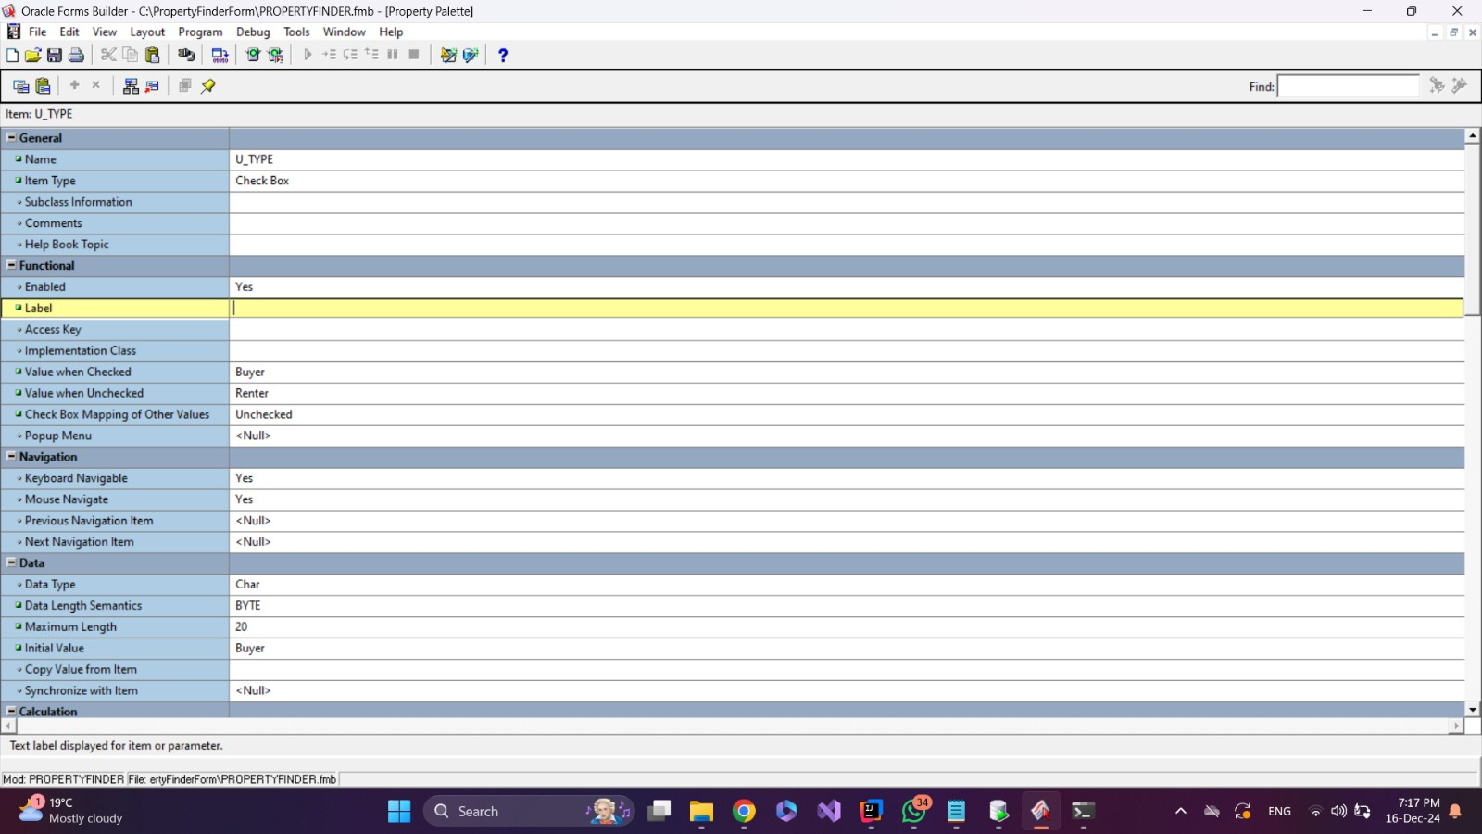

Make the LOV (location details) automatically displayed in Property data.

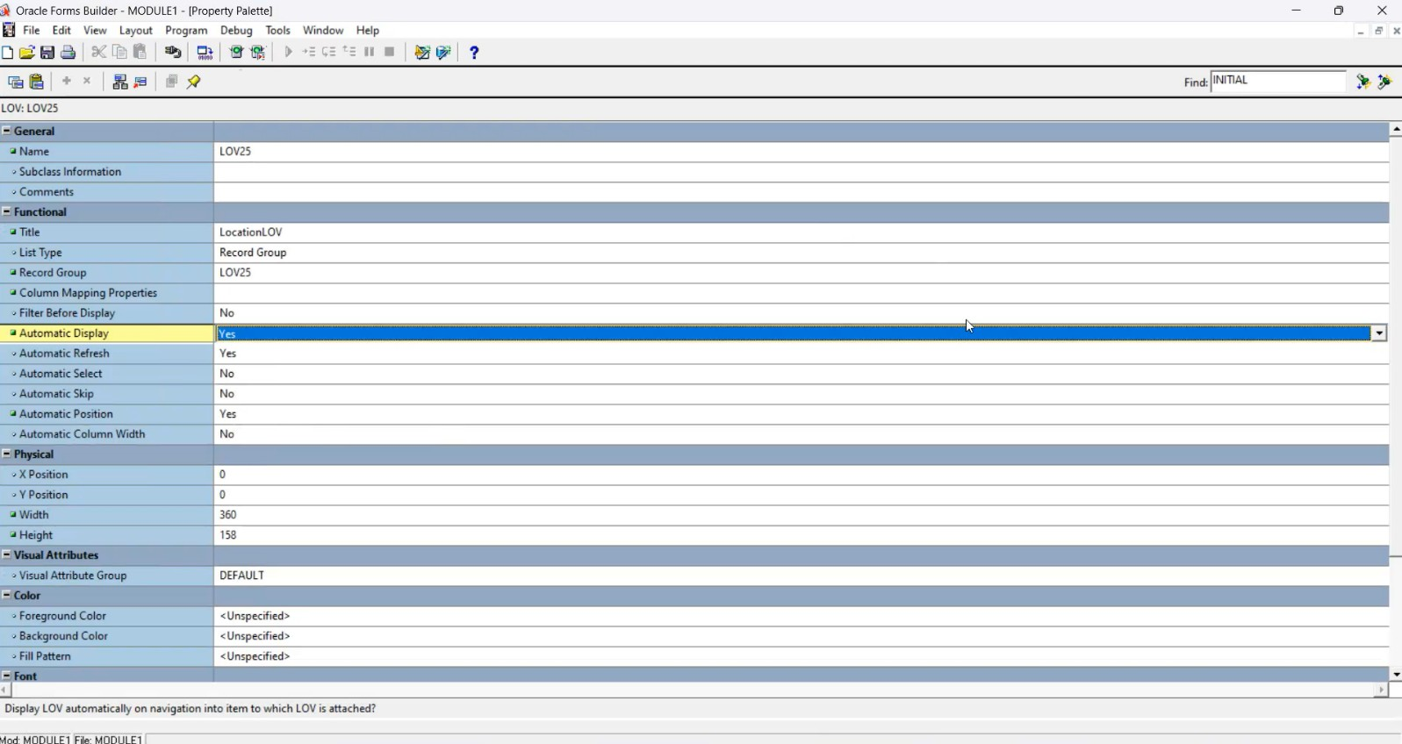

* Location details are displayed with Property data by LOV.

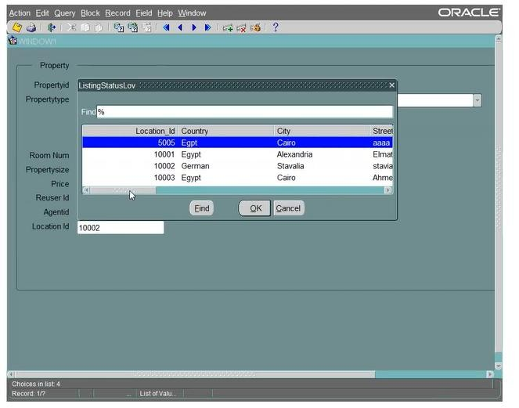

From the property palette of the listing status item, set mapping of other value and initial value.

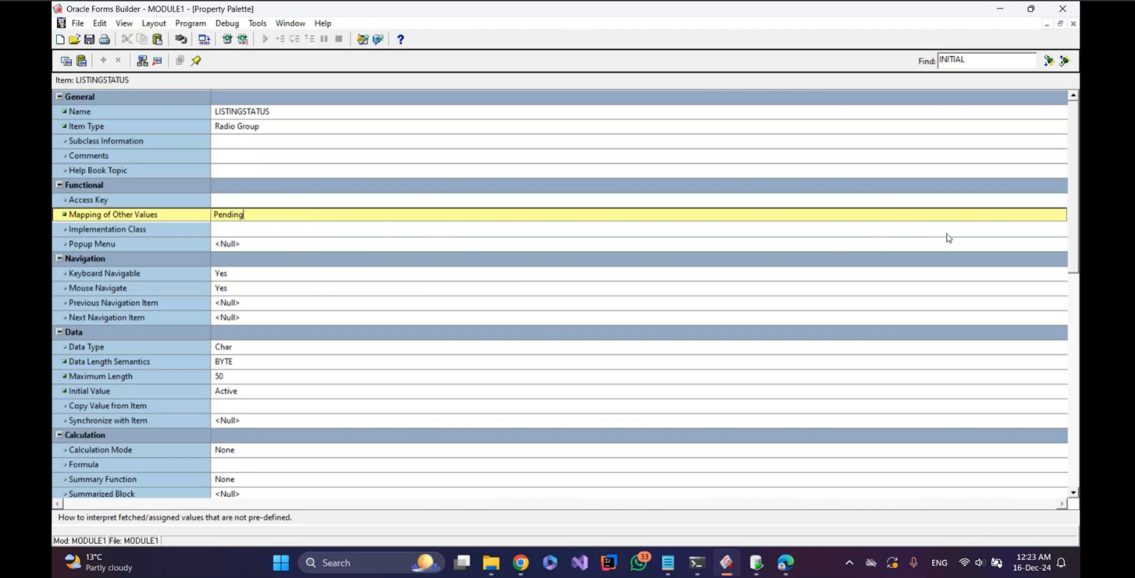

* Make the list item have style combo box for property type and set the initial value with (villa).

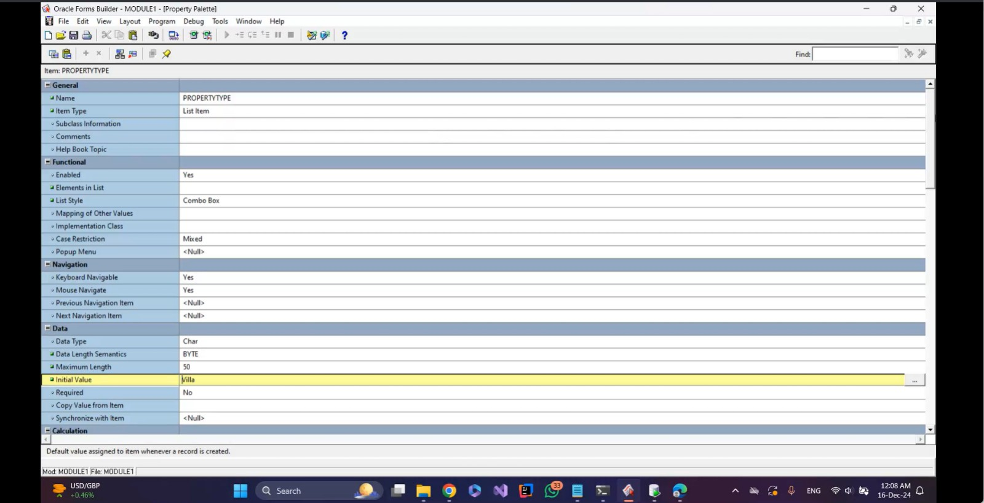

Alert logic (if rating is less than 1 or more than 5, alert message appears).

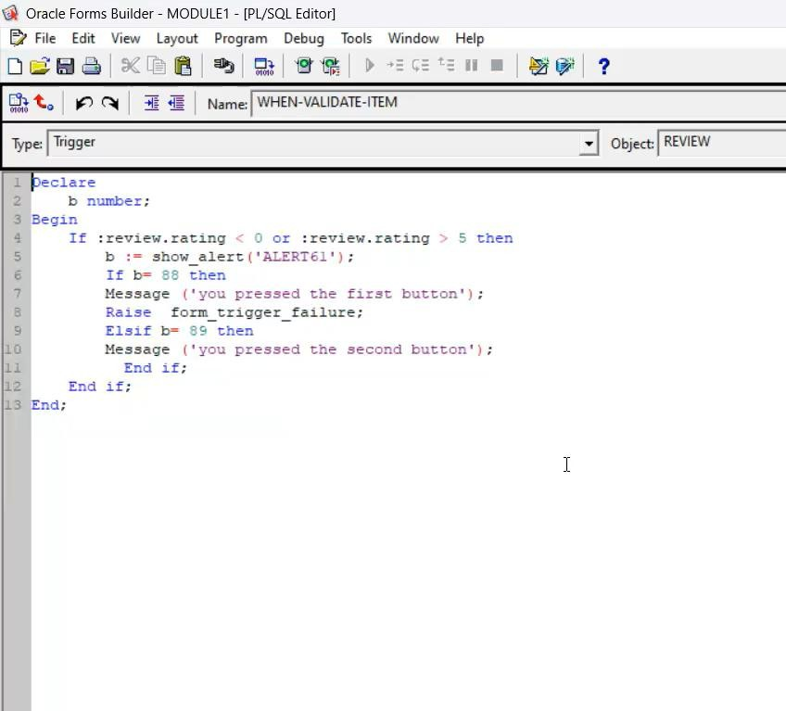

* Alert result.

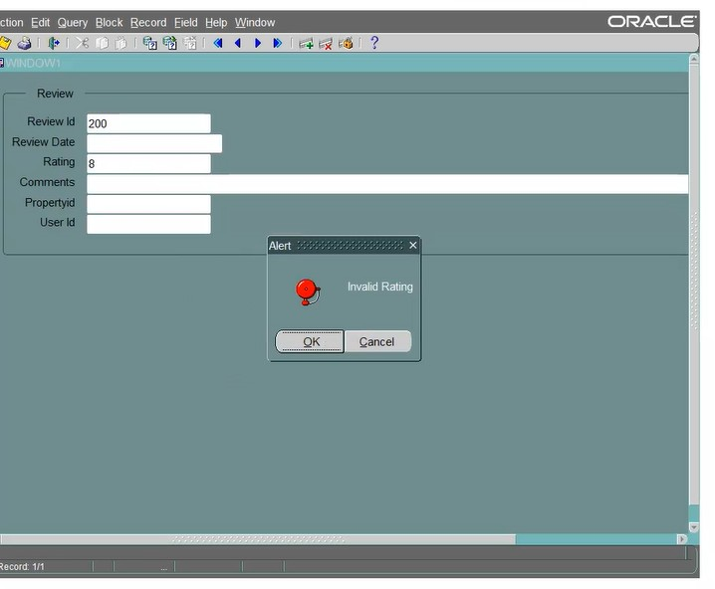

Create relation between agent and property table and check on auto join data blocks then set property in same canvas and set table as tabular

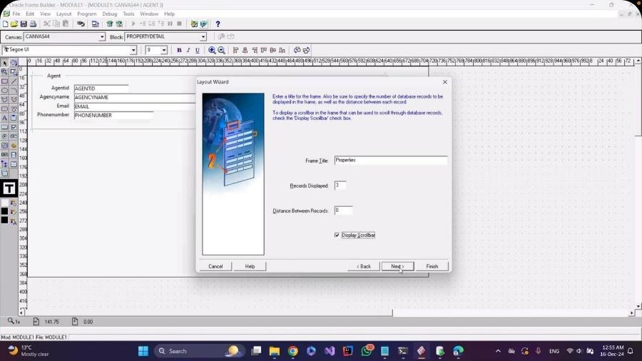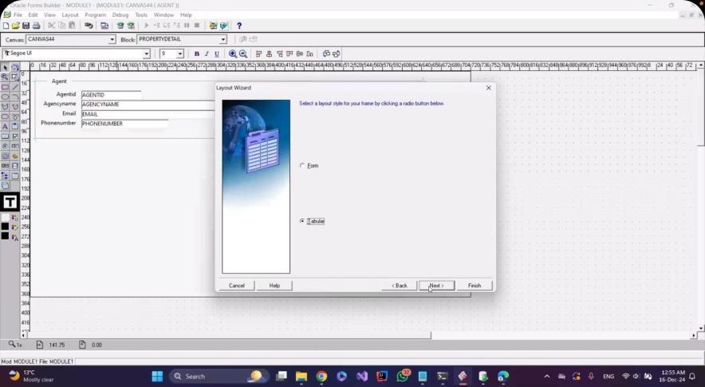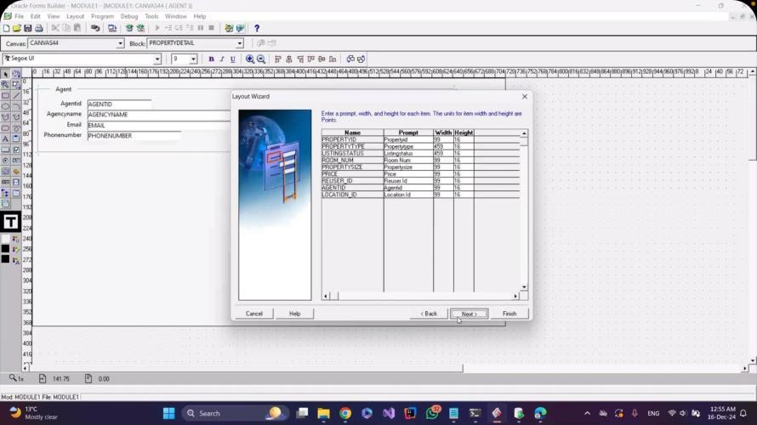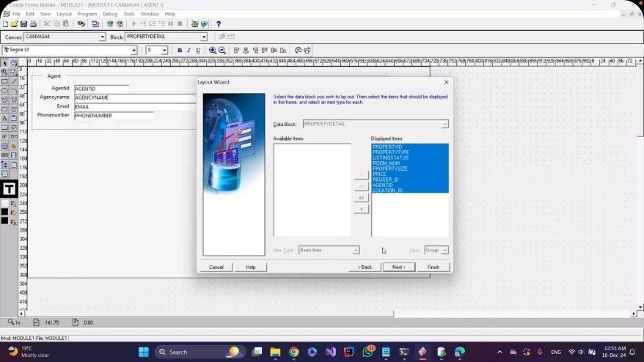

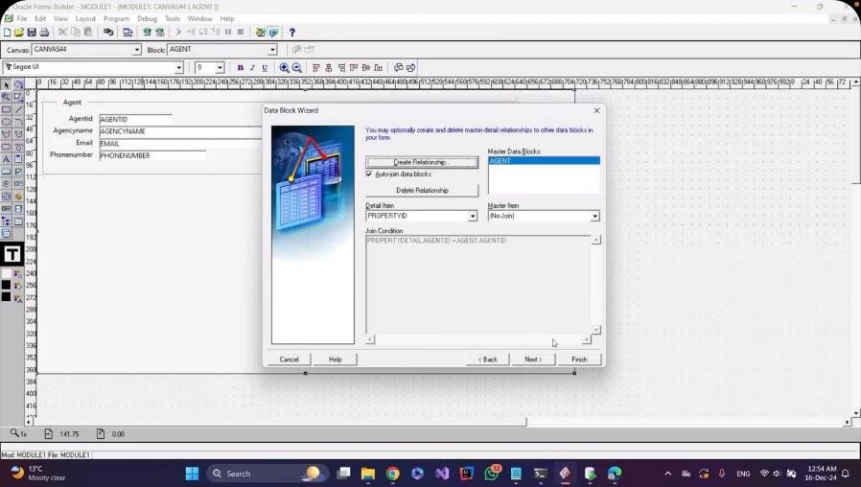

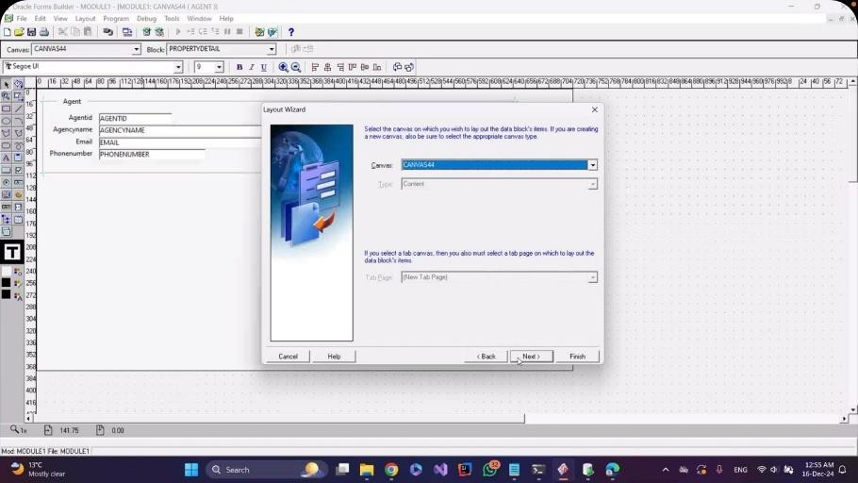

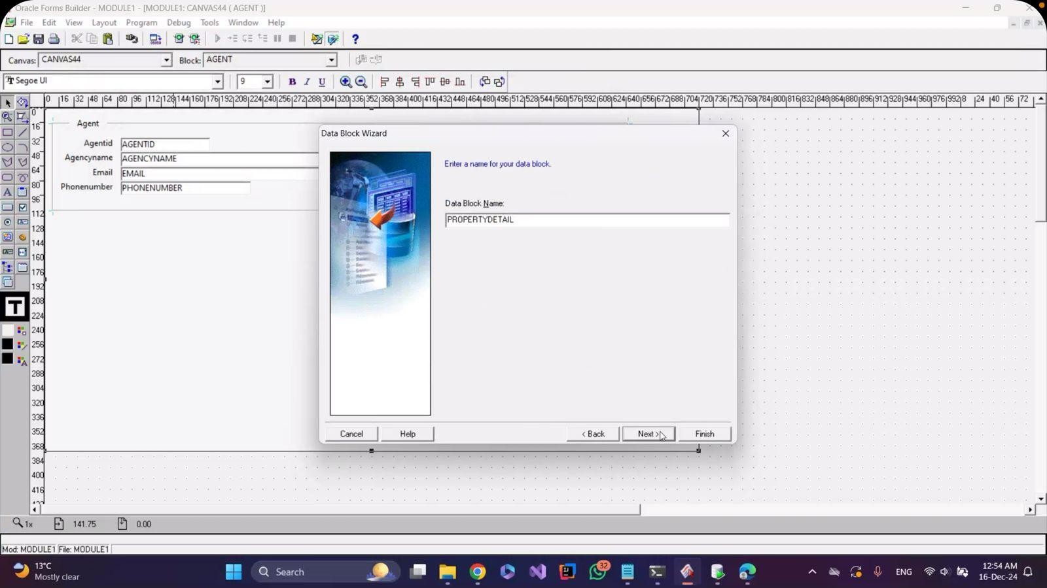

* From relation property set atumatic quary ( yes) to desplay all data in same time

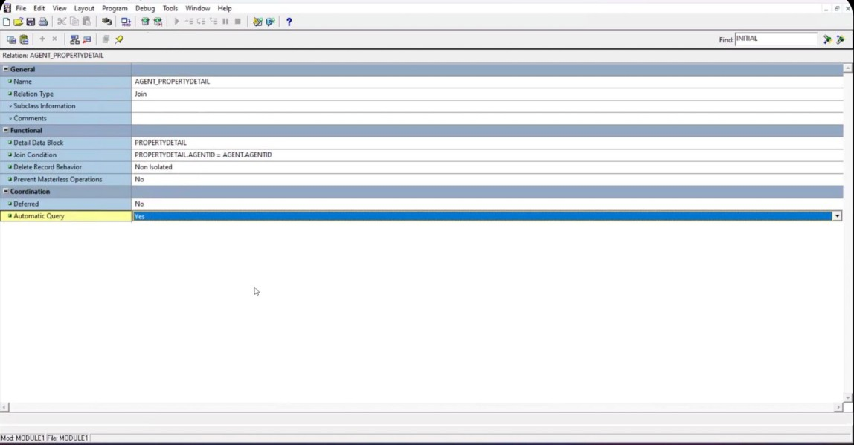

* Put item max price in property canves and set it in summary formula

